Unit 28 Spelling Words
r-controlled vowels

List Words:
- far
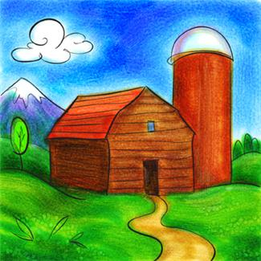
- farm
- art
- park
- car
- part
- dark
- star
- hard
- arm
Challenge Words:
- isn’t
- can’t
- wouldn’t
- didn’t
- it’s
- won’t
Sentences to Learn:
- I can’t park the car in the dark.
- It’s hard to see the star so far away.
Best wishes on a perfect score.

