Unit 19 Spelling Words
Consonant Clusters

List Words:
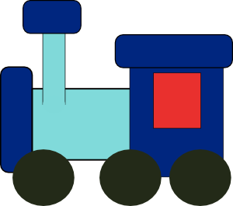
- fly
- clean
- sleep
- free
- grade
- drive
- train
- tree
- please
- slow
Challenge Words:
- braid
- grease
- pleat
- sleeve
Sentences to learn:
- Please drive to meet the clean train.
- The braid fell out when I went to sleep.
*Best wishes on a perfect score.*

