Unit 17 Spelling Words
c, k, ck
List Words:
- cook
- sick
- cave
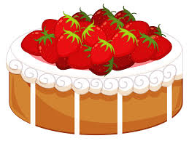
- kiss
- rock
- cake
- kick
- lock
- look
- luck
Challenge Words:
- cast
- pike
- dock
- tackle
- clock
- truck
Sentences to Learn:
1. The cave was blocked by a rock.
2. The priest says prayers for the sick.
Best wishes on a perfect score.

