Unit 12 Spelling Words
Review

- all
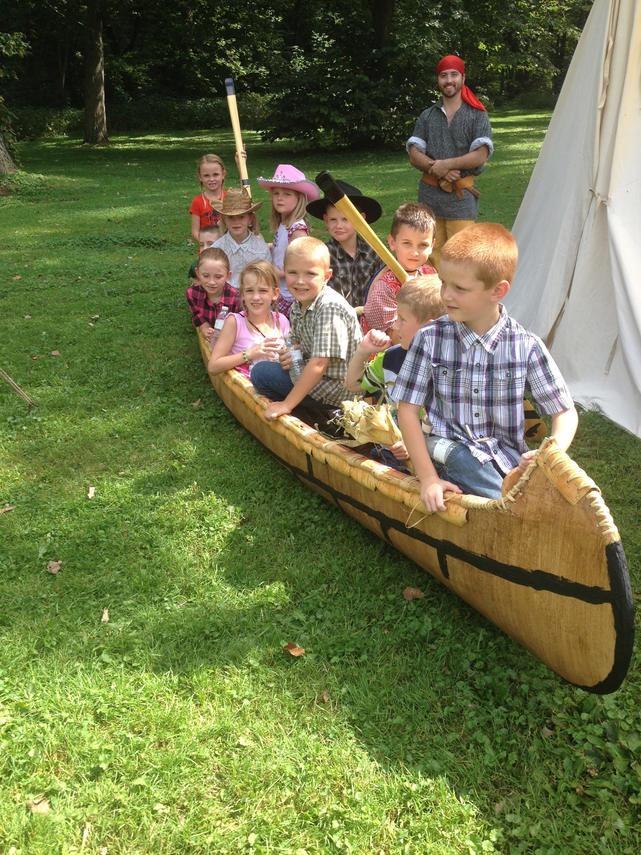
- talk
- small
- walk
- call
- glad
- grass
- plant
- front
- class
- bank
- sing
- drink
- long
- king
- said
- some
- been
- does
- have
- late
- joke
- fire
- cute
- base

