Spelling Unit 34
Homophones

List Words:
- deer
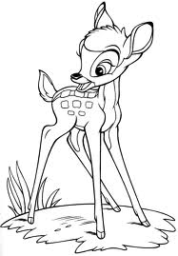
- here
- meet
- tale
- hour
- tail
- hear
- dear
- our
- meat
Challenge Words:
- tow
- reed
- weak
- aunt
Sentences to Learn:
- Did you hear that a deer was here?
- My aunt caught an ant by its tail.
- Listen to the tale of the reed by the pond.

Best wishes on a perfect score.

