Spelling Unit 27
Color Words

List Words:
- red

- blue
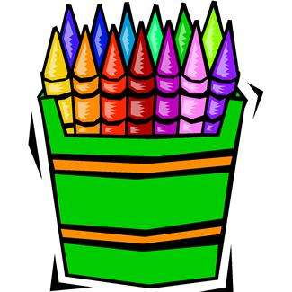
- yellow
- gray
- brown
- color
- black
- green
- pink
- white
Challenge Words:
- ivory
- orange
- purple
- violet
Sentences to Learn:
- I want sixteen yellow chicks.
- The blue sky looks pretty.
- Do you want orange or white flags?
Best wishes on a perfect score!

