Spelling Unit 23
Long and short oo

List Words:
- wood
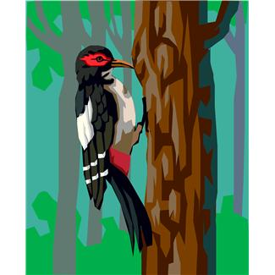
- took
- too
- noon
- good
- root
- book
- boot
- wool
- food
Challenge Words:
- moose
- scooter
- stood
- woodpecker
Sentences to Learn:
- Her boot was made of moose wool.
- We took a look at the woodpecker in the zoo.

