Spelling Unit 14
Advanced List

List Words:

- cook
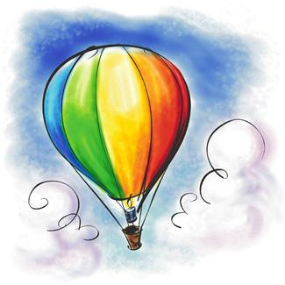
- knew
- put
- woods
- pull
- booth
- coop
- drew
- neighborhood
- afternoon
- balloon
- crooked
Challenge Words:
- playground
- repeat
- United States
- squeeze
- Wednesday
Sentences to Learn:
- I live in the United States of America.
- Do you see the balloon on the playground?

Best wishes on a perfect score!

