Spelling Unit 11
Vowel-consonant-e

List Words:
- cute
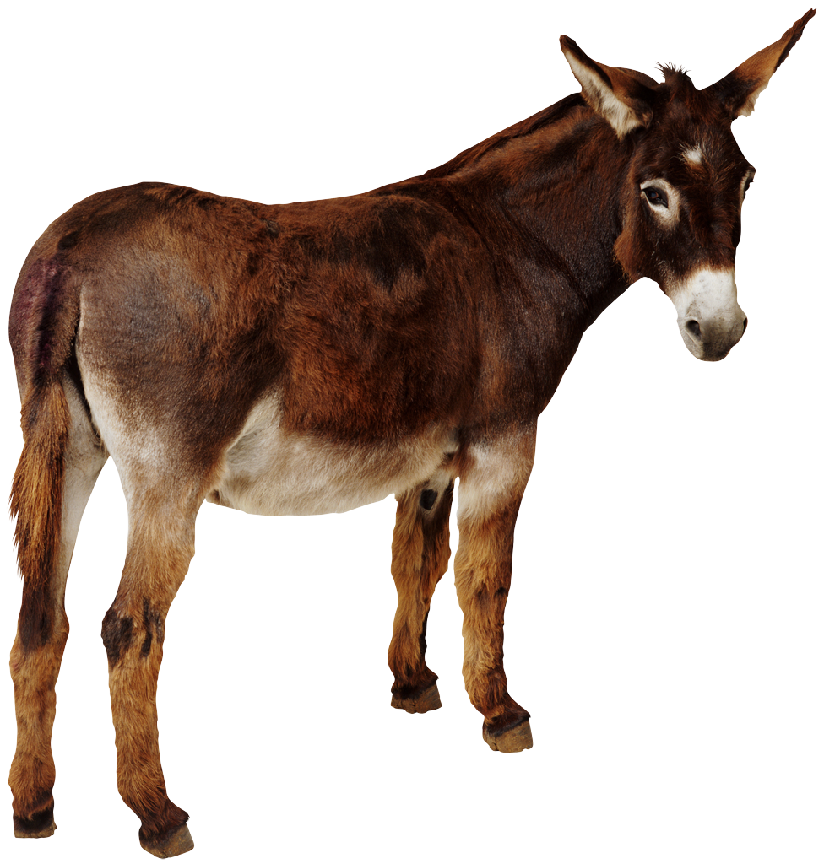
- wave
- robe
- late
- mule
- tape
- joke
- fire
- pipe
- base
Challenge Words:
- chute 4. zone
- crate 5. froze
- twine 6. hopefully

Sentences to Learn:
- Let’s wave to the cute mule.
- The pipe froze in the cold zone.
- Tape the base of the crate.
Best wishes on a perfect score.

